**[AI and ML in shaping the future of Autonomous Vehicles and safety protocols]**

**About Us: Emerging EV Charging Solutions**

|  |
| --- |
| Welcome to the world of Positive Charge, a pioneering force in the electric vehicle (EV) charging industry. We are committed to transforming the way fleets charge their EVs, providing efficient, sustainable, and future-ready solutions. In this case study, discover how we are reshaping the EV charging landscape. |

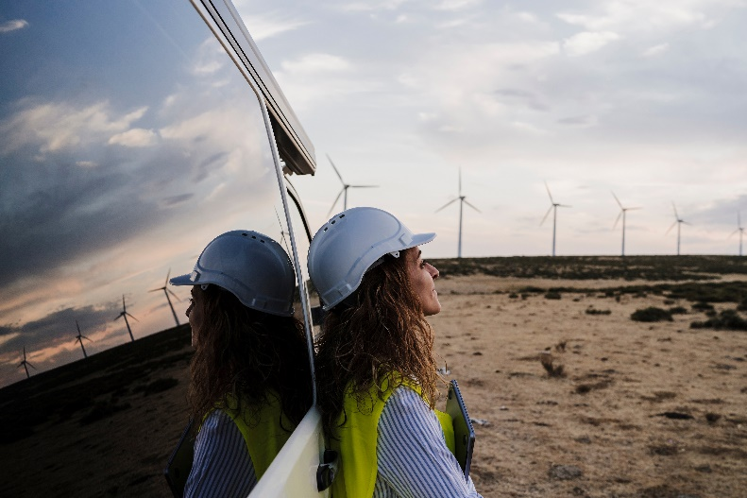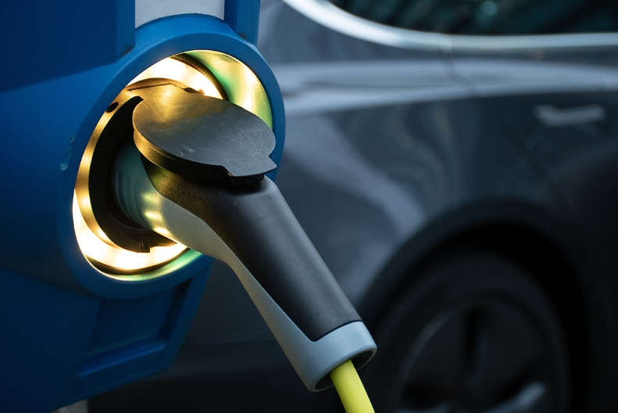

**Challenge: Overcoming Charging Bottlenecks**

|  |
| --- |
| The challenge at hand was monumental. Our client, an EV fleet management company, faced a critical problem — an expanding fleet that strained its existing charging infrastructure. This bottleneck led to downtime, inefficiency, and escalating operational costs. |

**Case Study: Driving EV Charging Transformation**

Welcome to our case study, where we take you on the journey of EV charging transformation. Explore the milestones, strategies, and collaborative effort that reshaped the course of charging operations.



**Solution: Smart Charging Redefined**

Our solution redefined smart charging for EV fleets. Engage with visually stunning elements that unveil how our integrated approach combined infrastructure expansion, smart technology, and optimized schedules to address the challenge.

**Benefits: Empowering Efficiency and Growth**

Visualize the benefits our customer reaped through our solutions. Immerse yourself in dynamic graphs, before-and-after scenarios, and impactful images. Witness how our strategies resulted in efficiency, cost savings, and operational excellence.

**Results: Numbers That Shout Success**

The quantifiable results of our efforts are breathtaking. Dive into dynamic charts and images that amplify the visual impact of our solutions. Discover how we leveraged tangible metrics to transform charging operations.

**Future:   
Shaping Tomorrow’s Charging Landscape**

|  |
| --- |
| Our journey does not end here. Peer into the future with us as we share our vision and strategies for continued success. Let our forward-looking approach and dynamic design elements inspire confidence in your look ahead. |

|  |
| --- |
| **DISCLAIMER**  Any articles, templates, or information provided by Smartsheet on the website are for reference only. While we strive to keep the information up to date and correct, we make no representations or warranties of any kind, express or implied, about the completeness, accuracy, reliability, suitability, or availability with respect to the website or the information, articles, templates, or related graphics contained on the website. Any reliance you place on such information is therefore strictly at your own risk. |